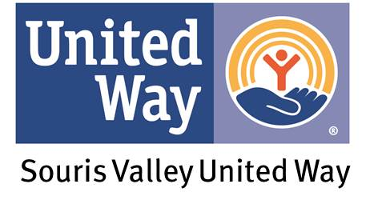
2019 SPIN UNITED TEAM REGISTRATION FORM
Donations are tax deductible through the Souris Valley United Way’s 501c3.
SPONSOR/BUSINESS NAME: ____________________________________________________________________________________
TEAM NAME: __________________________________________________________________________________________________
RIDER 1: ___________________________________ E-MAIL: ____________________________________________________________
PHONE NUMBER: _____________________________________
RIDER 2: ___________________________________ E-MAIL: ____________________________________________________________
PHONE NUMBER: _____________________________________
RIDER 3: ___________________________________ E-MAIL: ____________________________________________________________
PHONE NUMBER: _____________________________________
RIDER 4: ___________________________________ E-MAIL: ____________________________________________________________
PHONE NUMBER: _____________________________________
RIDER 5: ___________________________________ E-MAIL: ____________________________________________________________
PHONE NUMBER: _____________________________________
RIDER 6: ___________________________________ E-MAIL: ____________________________________________________________
PHONE NUMBER: _____________________________________

WE WILL PAY BY ($210 PER TEAM OR $35 PER PERSON):
_____CASH
_____CHECK
_____CREDIT CARD

PLEASE PRINT ONE DONATION SHEET FOR EACH RIDER TO TRACK FUNDS RAISED IN ORDER TO BE ENTERED FOR A CHANCE TO WIN A GIFT CARD/PRIZE AT THE EVENT!
Return all information to the United Way Office before March 22nd. (Make all checks payable to Souris Valley United Way.) Please contact Jalisa Andreasen at (701) 839-2994 or svuwcampaign@srt.com if you have questions. Thank you!

